AWS Site-to-Site VPN
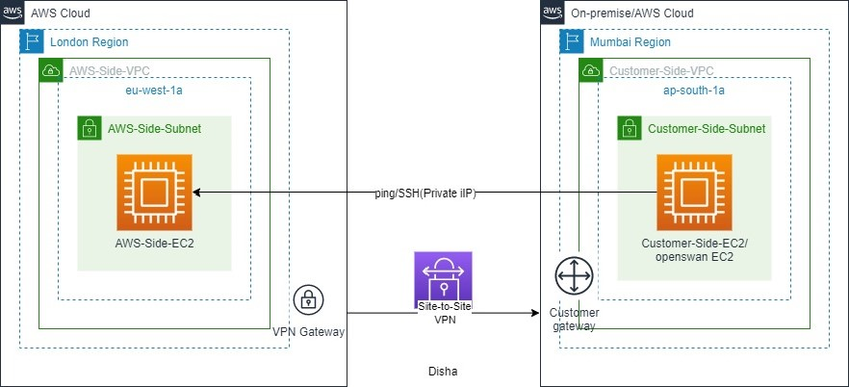
VPN can be categorized into two types:
1. Site-to-site VPN
2. Client to Site VPN
In this article, we specifically focus on the AWS Site to Site VPN setup and configuration.
VPN is a logical private encrypted connection that uses the public internet as its backbone infrastructure.
Virtual Private Gateway is a managed gateway endpoint for the VPC (Virtual Private Cloud) and is responsible for all the hybrid IT connectivity. The anchor on the provider side of the VPN connection is called a virtual private gateway.
Customer Gateway Device is a physical or software appliance, which is managed on-prem. A resource that is installed on the customer side.
Customer Gateway represents the customer gateway devices on the AWS side.
ASN is an independent network under the control of a single scope of administration. Here all internal routing occurs adhering to similar routing protocols. While creating a virtual private gateway, we can specify the private Autonomous System Number (ASN) for the AWS side of the gateway. If we do not provide an ASN, then AWS will assign its default ASN (64512).
Let’s get started.
Step1. Configure Network in London Region:
1. Create a VPC:
Name: AWS-Side-VPC with CIDR block 10.1.0.0/16. 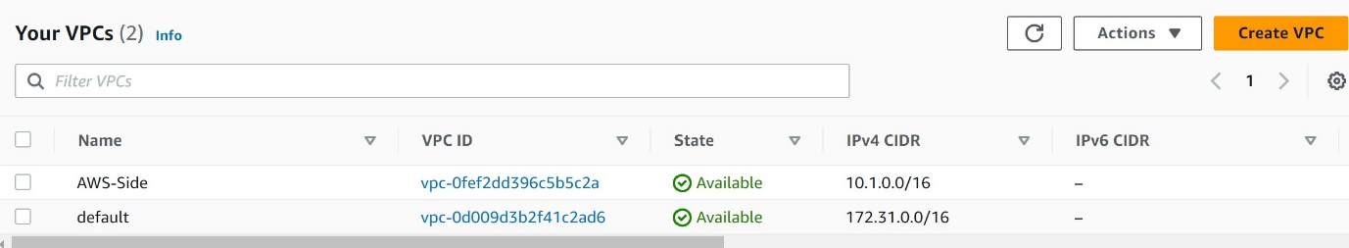
2. Create Public Subnets in AWS-Side-VPC:
Name: AWS-Side-Subnet with CIDR block 10.1.0.0/24.
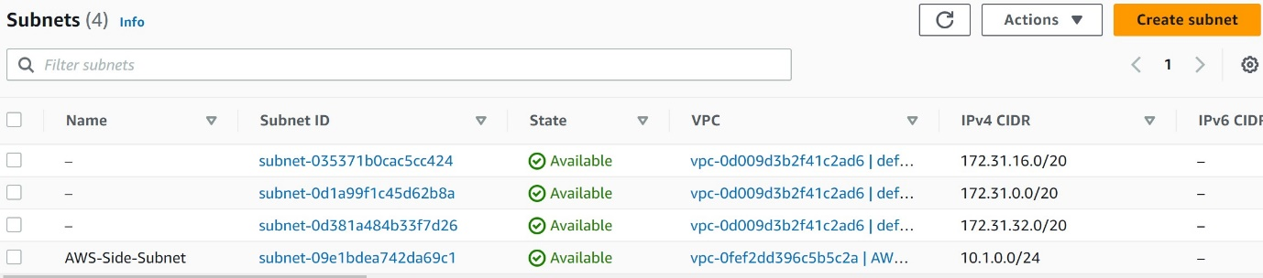
3. Create Internet Gateway in AWS-Side-VPC and attach it:
Name: AWS-Side-IGW attached to AWS-Side-VPC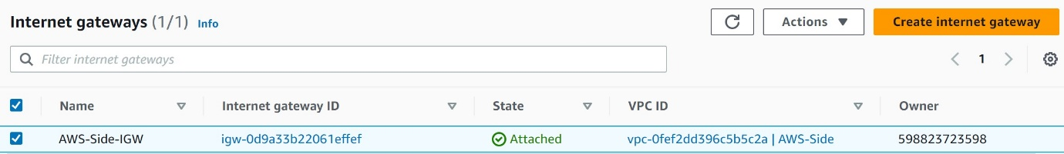
4. Modify Default Route Table in AWS-Side-VPC:
Names: AWS-Side-RT; Routes: Local,0.0.0.0/0 AWS-Side-IGW
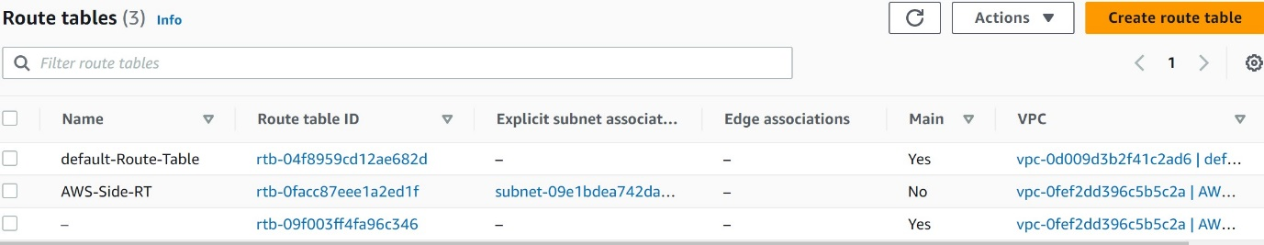
Step2. Configure Network in Mumbai Region:
- Customer-Side-VPC with CIDR block 10.2.0.0/16.
- Customer-Side-Subnet with CIDR block 10.2.0.0/24.
- Customer-Side-IGW attached to Customer-Side-VPC and attach it.
- Customer-Side-RT; Routes: Local,0.0.0.0/0 Customer-Side-IGW
Step3. Initialize EC2 on each VPC.
- Create Security Group for EC2 in AWS Side:
Create a new security group: AWS-Side-SG
Type: SSH; Source: My IP
Type: All TCP; Source: Custom, 10.2.0.0/16
Type: All UDP; Source: Custom, 10.2.0.0/16
Type: All ICMP - IPv4; Source: Custom, 10.2.0.0/16
- Create Security Group for EC2 in Customer Side:
Create a new security group: Customer-Side-SG
Type: SSH; Source: My IP
Type: All TCP; Source: Custom, 10.1.0.0/16
Type: All UDP; Source: Custom, 10.1.0.0/16
Type: All ICMP - IPv4; Source: Custom, 10.1.0.0/16
- Create EC2 in AWS-Side network:
AMI: Amazon Linux 2
Instance type: t2.micro
Network: AWS-Side-VPC
Subnet: AWS-Side-Subnet
Auto-assign Public IP: Enable
Security group: AWS-Side-SG
Key pair: Create a new key pair: aws-side-key.
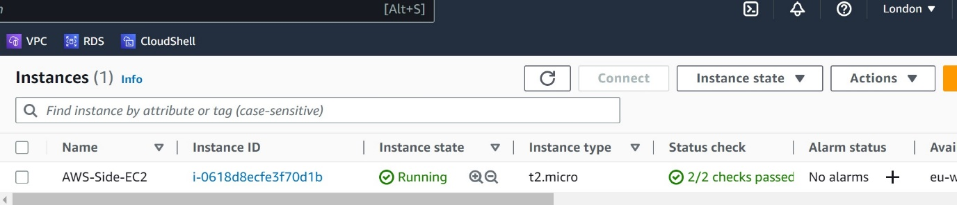
- Create EC2 in Customer-Side network:
AMI: Amazon Linux 2
Instance type: t2.micro
Network: Customer-Side-VPC
Subnet: Customer-Side-Subnet
Auto-assign Public IP: Enable
Security group: Customer-Side-SG
Key pair: Create a new key pair: customer-side-key.
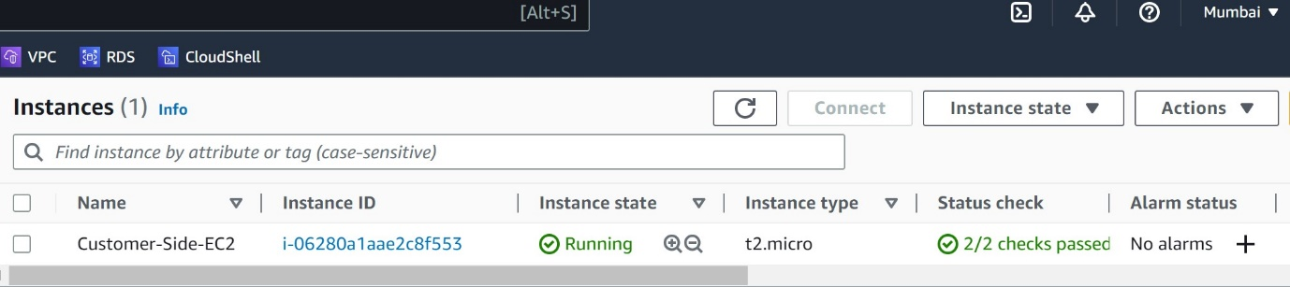
Step3. Configure Site to Site VPN at AWS-Side.
- Create Virtual Private Gateway at AWS-Side and attach to VPC–AWS-Side-VPC
Name: AWS-Side-VPG
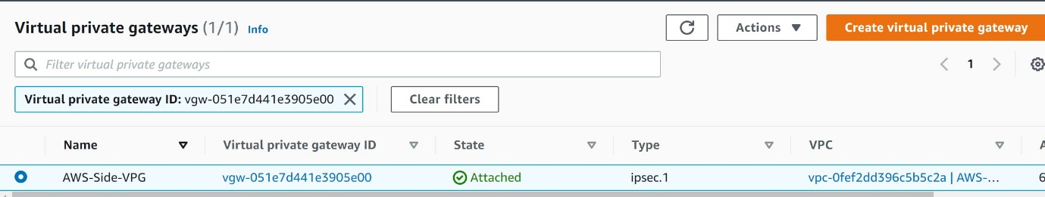
- Create & configure Customer Gateway at AWS-Side
Name: AWS-Side-CGW
Routing: Static
IP Address: Enter Public IP of Customer-Side-EC2 instance.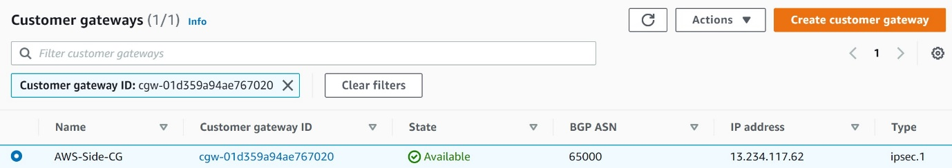
- Create & configure Site-to-Site VPN connection at AWS-Side
Name: London-Mumbai-VPN
Virtual Private Gateway: AWS-Side-VPG
Customer Gateway: Exist (AWS-Side-CGW)
Routing Options: Static
IP Prefixes: 10.2.0.0/16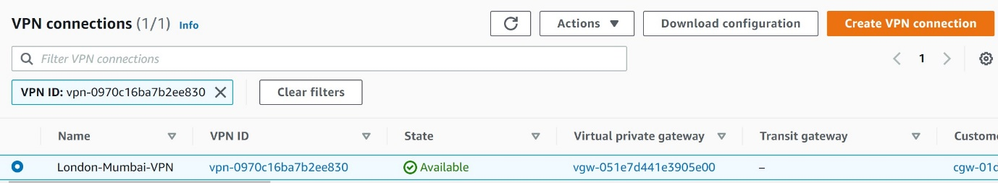
Under the Tunnel Details tab, we can find details about our VPN tunnel.
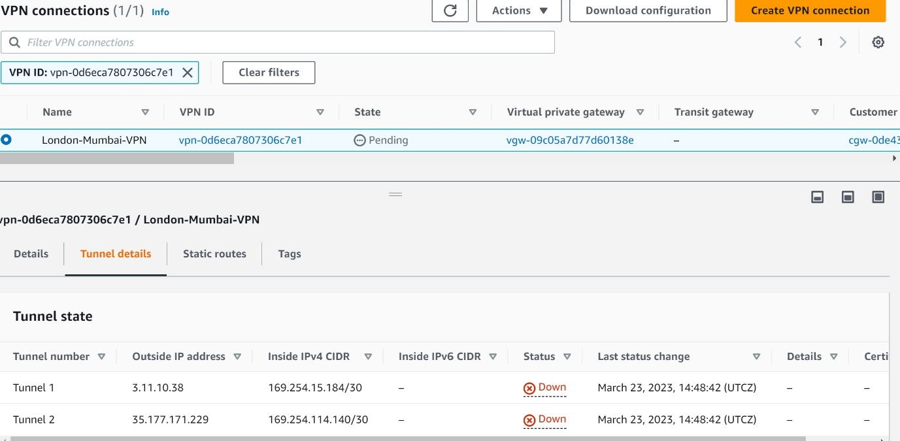
For high availability and redundancy, AWS provides two VPN tunnels. These tunnels are used in active-passive mode.
Go to Site-to-Site VPN-London-Mumbai-VPN – download configuration, change vendor-Openswan and then download.
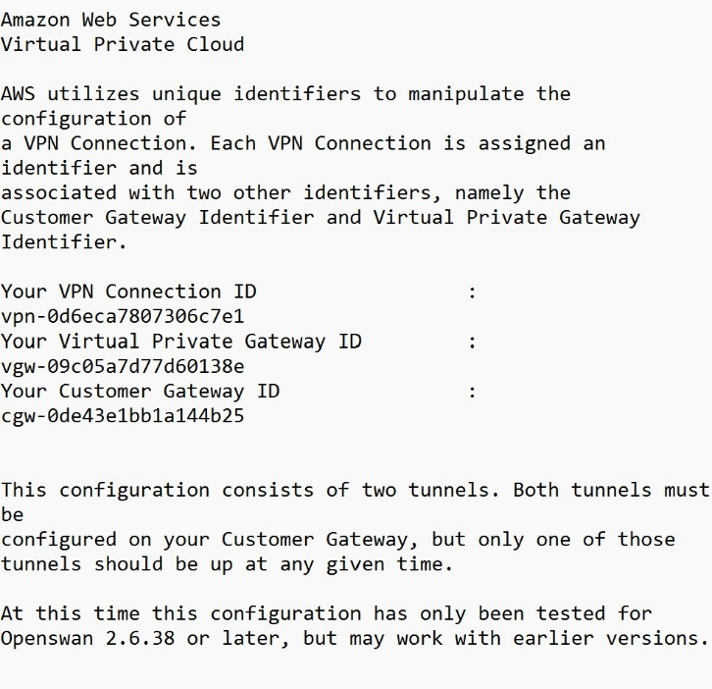
- Enable propagate for Route table of AWS-Side-RT:
Click Route Propagation, Edit Route Propagation, Check Enable, Yes
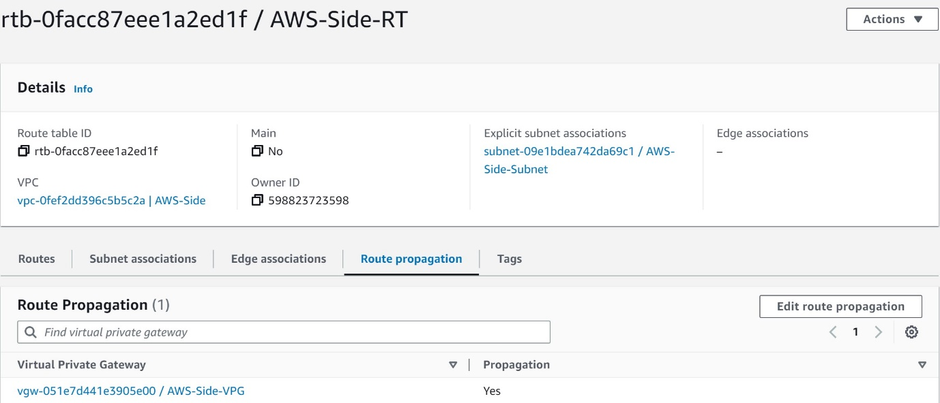
Step4. Configure Site to Site VPN at Customer-Side
On Customer-Side-EC2 do followings:
Install OpenSwan
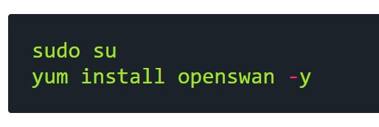
Configure /etc/ipsec.conf
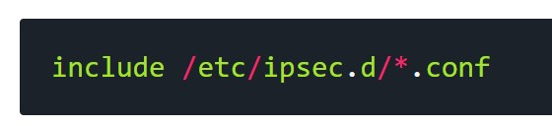
Configure /etc/sysctl.conf
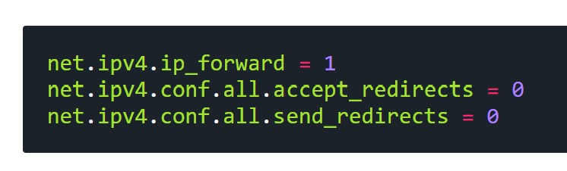
Configure /etc/ipsec.d/aws-vpn.conf
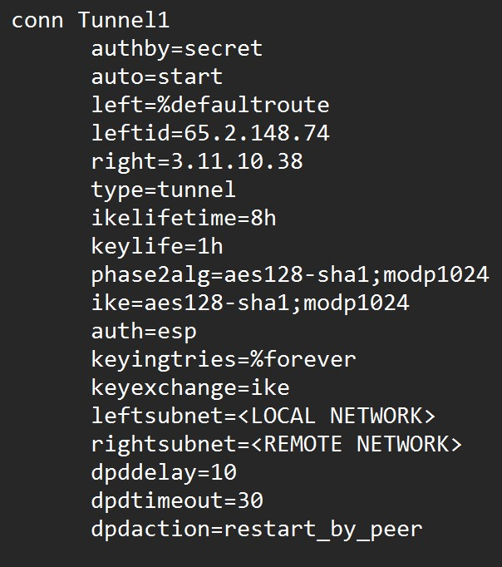
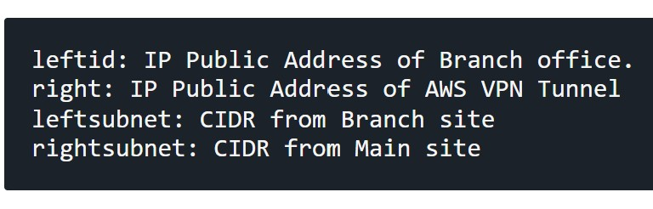
Configure /etc/ipsec.d/aws-vpn.secrets
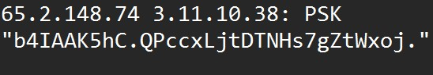
Configure Service network restart
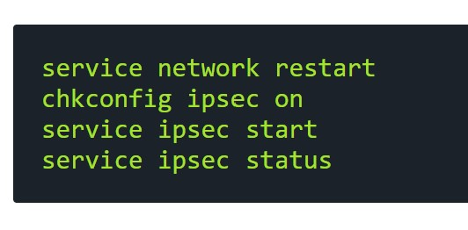
Step5. Test ping from AWS-Side-EC2 to Customer-Side-EC2
